Little SPARK: Simple Play Adaptations to Reference for Kids

Core and Fringe Picture Communication Carrier
Description: | Image:
The Core and Fringe Picture* Communication Carrier is a portable waist display for CORE + Fringe vocabulary for communication. Personalized CORE + Fringe pictures can be inserted into provided vinyl pockets. | 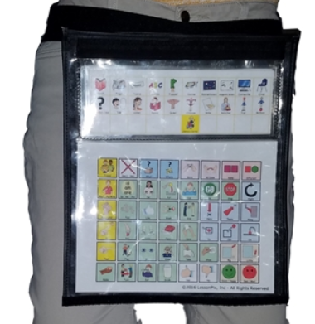

Who Might Benefit?
Those who need symbol support and a means of transporting their communication support to express and receive information at any given time.
Why Use?
Provides an opportunity to communicate on-the-go with a variety of communication symbols.
Instructions for Use: | Adaptation Ideas:
Environmental Considerations  - Use in any environment and on the go.  Positioning & Alternate Positioning  - Use in any position or attach to a slant board.  Basic Play/Use  - Introduce a symbol/visual support page, explain what it is and how it is used, and be consistent and make sure it is accessible.  Extended Play/Use  - Model use of the carrier. | Build It Up  - Edges could be built up or tabbed for easy gripping or high contrast.  Simplify It  - Introduce a few visuals at a time.  Stabilize It  - Velcro to most surfaces.  Add Sensory Cues  - Add contrasting backgrounds, high contrast visuals, or tab/color code pages.  Alternative Uses  - Use to display schedules, task sequences, etc.

DIY Alternatives
Purchase double sided trading card collector sleeves (9 pockets to standard notebook sized sheets) and insert visuals into pockets. Place sheets in a standard 3 ring binder.
Create a wearable communication notebook from a 3-ring binder (3-ring binders come in a variety of sizes) and add a carrying strap.
  - Cut and laminate various colored tabbed file folders
  - Add strips of Velcro for attaching visuals
  - Punch holes in pages and insert into notebooks
  - Label tabs

